UXP-HTML5-L1-0001: HTML5 Login Registration Form

Level: L1

Technologies: HTML5, CSS3, Bootstrap**.**

**Case Study – HTML5 Login Form**

Visual:

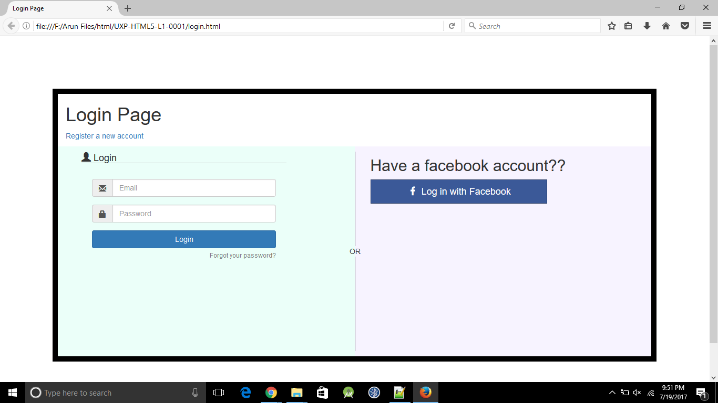

Figure 1 Main page

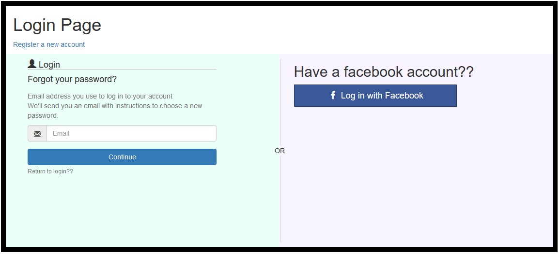

Figure 2 On click on forgot password redirect to this page

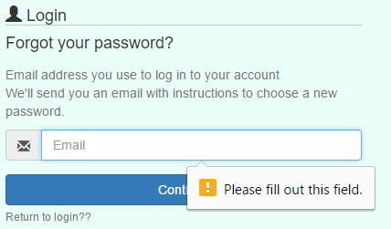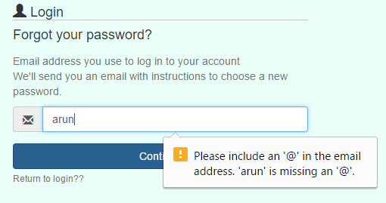

Figure 3 Email validation

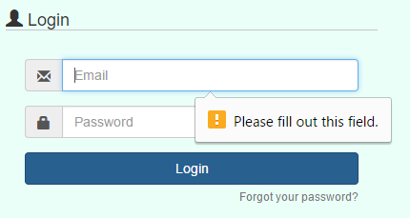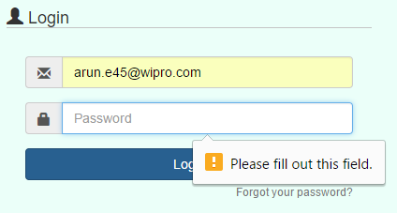

Figure 4 Login form validation

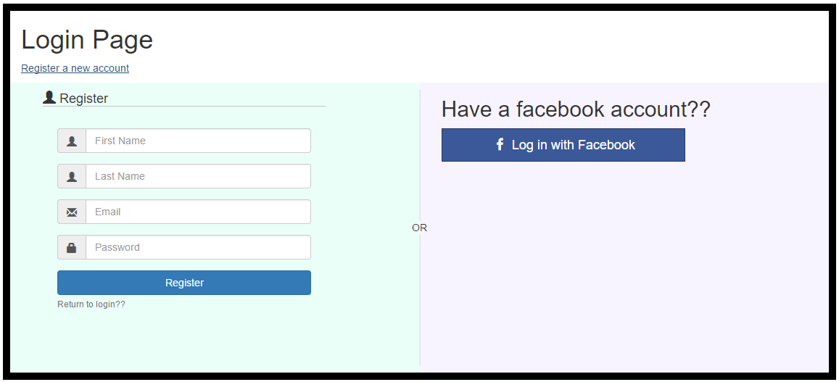

Figure 5 On click of Register a new account link opens this page

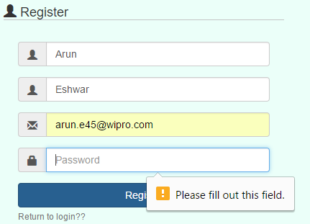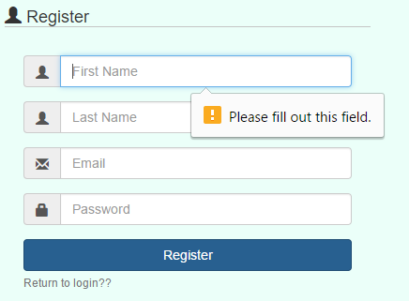

Figure 6 Register form validation



Figure 7 On click Facebook login button this page opens in new tab

